Dual-Layer Provenance for AI-Generated Artifacts
  - Explicit Watermarks and Forensic Fingerprints as Evidence Infrastructure
Denzil Greenwood
Founder and Head Researcher, CognitiveInsight.ai
April 2026
Working paper draft
Abstract
Provenance for AI-generated artifacts becomes materially harder once outputs leave the originating runtime environment and are copied, edited, reformatted, excerpted, or intentionally stripped of visible markers. This paper argues that downstream provenance requires two complementary layers rather than a single mechanism: an explicit watermarking layer that signals origin directly, and a forensic fingerprinting layer that preserves evidentiary linkage when explicit marks are removed, degraded, or disputed. Framed within AI governance evidence infrastructure, the proposed model connects runtime generation evidence to distributed artifact evidence through dual-state hashing, watermark-bearing exports, and post-distribution forensic verification. The paper explains why a single provenance mechanism is insufficient in real-world disputes, describes a dual-layer architecture for downstream verification, outlines investigator workflows, and identifies limitations including removability, format conversion, partial excerpts, and false-positive discipline. The contribution is not a generic AI-detection claim; it is a governance and evidence claim about how organizations can preserve provenance and defensibility after artifacts leave controlled systems.
Keywords: AI provenance, watermarking, forensic fingerprinting, audit trails, evidence infrastructure, chain of evidence

1. Introduction
The provenance problem for AI-generated artifacts begins where many governance programs effectively end: after distribution. Inside a controlled application or model-serving environment, it may be possible to log prompts, model identifiers, retrieval context, policy checks, tool traces, and output hashes. Once an artifact is exported as a PDF, image, report, memo, or media file, however, the governance boundary weakens. Files can be copied, reformatted, partially excerpted, intentionally altered, or stripped of visible provenance markers. At that point, the central question is no longer merely whether the originating system behaved correctly, but whether the distributed artifact can still be linked back to a specific governed generation event.
This paper argues that a strong downstream provenance architecture requires two layers. The first is an explicit watermarking layer that signals origin directly through visible marks, metadata, embedded tags, or structured overlays such as QR codes. The second is a forensic fingerprinting layer that seeks to preserve evidentiary linkage even when explicit markers are removed or degraded. These layers serve different purposes. Watermarks are useful for immediate signaling, controlled distribution, and low-friction verification. Forensic fingerprints are useful when artifacts are disputed, edited, transformed, or partially reproduced in ways that weaken direct markers.
The claim of this paper is therefore narrower and more disciplined than a broad content-detection claim. The goal is not to prove authorship in the abstract, nor to solve every dispute about synthetic content. The goal is to extend AI governance evidence infrastructure beyond runtime systems into the artifacts themselves, so that provenance remains inspectable after files leave the original application boundary.

2. Provenance Requirements for Distributed Artifacts
A useful provenance model for distributed artifacts must satisfy at least four requirements. First, it must be durable enough to survive ordinary handling. Second, it must be verifiable by a reviewer who did not originate the artifact. Third, it must support dispute handling when an artifact is altered or only partially available. Fourth, it must integrate with an upstream evidence system rather than functioning as a disconnected novelty feature.
Durability matters because distributed artifacts commonly undergo benign transformations such as file conversion, compression, page extraction, screenshotting, printing, OCR, or text copy-and-paste. A provenance method that fails under ordinary handling has limited governance value. Verifiability matters because the relevant reviewer may be an internal auditor, investigator, outside counsel, regulator, counterparty, or customer. The method cannot assume access to the originating runtime or trust in the originating vendor. Dispute handling matters because the strongest provenance questions arise precisely when evidence is contested. Finally, integration matters because downstream provenance should connect back to lifecycle receipts, approval state, and policy context established elsewhere in the evidence architecture.
These requirements distinguish evidence-grade provenance from simplistic tagging. A filename convention, UI badge, or mutable metadata field may be operationally convenient, but it does not provide resilient evidentiary linkage. The provenance system must be designed for verification under friction, not just visibility under ideal conditions.

3. Explicit Watermarking Layer
The explicit watermarking layer is the direct-signaling component of the architecture. It may include visible overlays, structured footer markers, QR codes, embedded metadata, steganographic payloads, or other explicit provenance cues attached at the moment of export or release. Its purpose is not only branding or notification. Properly implemented, an explicit watermark becomes a first-line verification mechanism that tells a reviewer where to look, what record to match, and which evidence object should correspond to the artifact.
A key design feature in this paper’s framing is dual-state hashing. Before a watermark is embedded, the system computes a hash over the canonical pre-watermark artifact. After watermark embedding, it computes a second hash over the distributed artifact state. This yields two linked evidence points: one representing the pristine content state and one representing the released, watermark-bearing state. Dual-state hashing is useful because disputes may concern either whether a distributed file is authentic as released or whether the released file faithfully corresponds to the original governed content before provenance marking.
Visible watermarking is especially effective in controlled-distribution settings such as board materials, internal reports, regulated decisions, or customer-facing exports where the organization wants immediate provenance signaling. Embedded metadata or less-visible encodings can complement visible marks, but the central design principle remains the same: the explicit layer should make provenance legible, inspectable, and quickly resolvable when the mark survives.

4. Forensic Fingerprinting Layer
The forensic fingerprinting layer addresses a different problem: what happens when explicit markers are removed, degraded, cropped, retyped, partially excerpted, or deliberately disputed. In this paper’s framework, the forensic layer is not a generic “AI detector.” It is an evidence-preservation method that attempts to retain linkage between suspect artifacts and the originally distributed material even when direct markers are unavailable.
One practical approach is a distinctive-anchor method for text. The system extracts high-information segments across multiple zones of a document, scores candidate shingles using rarity or information-weighted measures, and stores a compact fingerprint that can later be matched against suspect text. A zone-based strategy supports partial-survival scenarios: if enough anchors persist in enough regions, an investigator can demonstrate a linkage claim stronger than coincidence while remaining disciplined about false positives. The same conceptual logic extends to images, PDFs, and multimodal objects through combinations of perceptual hashes, structural markers, and content-specific forensic features.
The forensic layer is valuable because real disputes rarely preserve ideal evidence conditions. Leaked documents may circulate as screenshots. Text may be copied into emails or chat. Pages may be reassembled. Watermarks may be blurred or cropped. In those cases, provenance has to survive through probabilistic but disciplined matching rather than direct marker recognition alone. That is why a single provenance mechanism is insufficient for governance and evidence use cases.

5. Verification Workflows
A downstream provenance system is only useful if investigators can apply it consistently. A typical verification workflow begins by identifying whether the suspect artifact still contains an explicit marker. If so, the reviewer extracts the visible identifier, QR payload, or metadata reference and queries the evidence system for the corresponding release record. The record should contain at minimum the release identifier, pre- and post-watermark hashes, timestamp, relevant policy context, and the governing runtime or workflow receipt.
If the explicit layer is missing or disputed, the workflow shifts to forensic verification. The reviewer derives candidate fingerprints or anchor matches from the suspect artifact, compares them against the evidence corpus, and evaluates whether the match exceeds the organization’s defined threshold for evidentiary use. The verification output should make clear what claim is being supported: exact artifact match, released-state match, pre-watermark content match, probable excerpt linkage, or no supportable linkage. Precision in claim formulation is essential.
A disciplined workflow also records the verification event itself. The act of checking provenance can produce a verification receipt capturing who performed the review, what artifact was examined, what methods were used, which evidence objects were matched, and what conclusion was reached. This matters because provenance verification may later itself become part of an audit, investigation, or dispute.

6. Evidence Use Cases
The most obvious use case is controlled distribution. Organizations often release AI-generated reports, decision memos, summaries, or customer-facing artifacts into environments where later origin questions may arise. An explicit watermark plus linked evidence record makes first-pass verification straightforward. A forensic layer provides a fallback when the artifact has been altered after distribution.
A second use case is audit and internal review. If an organization claims that certain outputs were generated by a governed workflow, approved under specific controls, and distributed only after review, downstream provenance helps substantiate that claim. Auditors can move from an artifact in hand to a release record, then from the release record to the associated lifecycle and approval evidence.
A third use case is legal dispute or leak investigation. In those settings, the relevant question may not be whether a file bears a logo or footer, but whether a suspect document is materially linked to a governed release event despite attempts at removal, excerpting, or transformation. This is where the dual-layer model is most valuable. It supports both simple verification when conditions are clean and deeper evidentiary investigation when conditions are adversarial.

7. Limitations and Adversarial Pressure
No provenance mechanism is perfect. Explicit watermarks can be removed, cropped, blurred, recompressed, or overwritten. Metadata can be stripped during routine conversion. Embedded marks may fail across formats. Forensic methods can degrade under heavy paraphrase, short excerpts, OCR noise, aggressive rewriting, or multimodal transformation. These are not edge cases; they are normal pressures that a serious provenance architecture must acknowledge.
For that reason, this paper emphasizes false-positive discipline and claim restraint. A provenance system must be explicit about what it can and cannot support. Exact-match verification, release-state verification, excerpt linkage, and probabilistic similarity should not be conflated. Organizations need thresholding policies, review procedures, and escalation rules that match the seriousness of the decision being made. The more consequential the decision, the stronger the expected corroboration should be.
Adversarial pressure also affects operational design. If provenance marks are obvious, they may become targets for removal. If forensic features are static, they may be easier to evade. If the verification process is opaque, it may be hard to defend in front of skeptical reviewers. These pressures do not defeat the category claim; they reinforce the need for a layered, evidence-conscious approach rather than reliance on a single mechanism.

8. Future Work
Several extensions follow naturally from the framework proposed here. First, multimodal provenance deserves fuller treatment. Text, images, audio, video, and compound documents each have different survivability and verification characteristics. Second, stronger evaluation methodologies are needed to characterize persistence, collision risk, and false-positive behavior under realistic transformations. Third, provenance schemas should be made more portable so that distributed-artifact evidence can be exchanged and validated across systems rather than only within a single vendor environment.
Another important area is standards alignment. Emerging provenance efforts in content authenticity and media metadata can provide useful adjacent patterns, but governance-oriented evidence infrastructure still requires stronger coupling between runtime generation events, release records, and downstream verification receipts. Future work should therefore distinguish between provenance signaling, content authenticity, and governance evidence while drawing on each where useful.
Finally, a mature downstream provenance architecture should be integrated with the broader lifecycle evidence system. Release decisions, approval state, access policy, and distribution context all matter when interpreting a watermark or forensic match. The long-term goal is not merely to label artifacts, but to make them reconstructable components of a larger accountability fabric.

9. Conclusion
Downstream provenance is a natural extension of the evidence-layer thesis for high-stakes AI. If governance evidence stops at runtime, then a critical part of the accountability problem remains unsolved, because artifacts often outlive, out-travel, and out-contextualize the systems that produced them. A robust provenance system must therefore support verification after export, copying, editing, and dispute.
This paper has argued that a two-layer model is the most practical way to do so. The explicit watermarking layer provides direct signaling and low-friction verification. The forensic fingerprinting layer provides a fallback when explicit marks are absent, degraded, or contested. Together, these layers connect distributed artifacts back to the governed evidence system in a way that is more resilient than either layer alone.
The result is not a generic detection proposal, but an evidence architecture for artifact provenance. In that role, watermarking and forensic fingerprinting become part of AI governance evidence infrastructure: not separate novelties, but the downstream custody and verification mechanisms that keep provenance meaningful after artifacts leave controlled systems.

Figure:
Figure 1. Two-layer provenance model
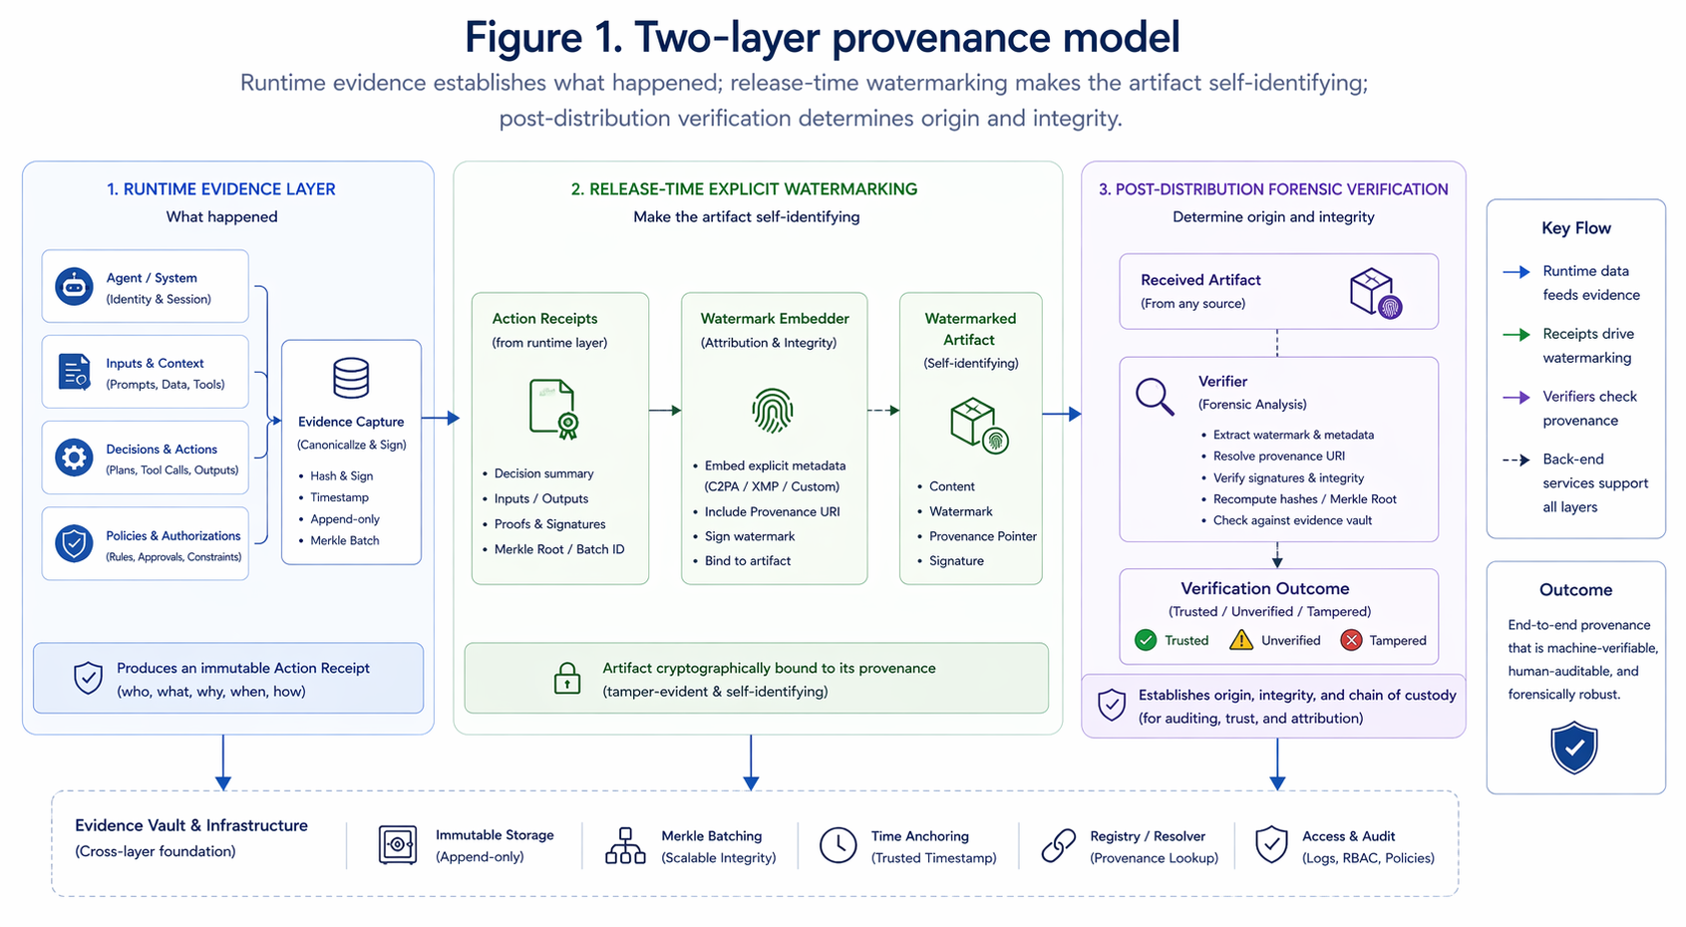
Figure 1. Two-layer provenance model for an architecture diagram showing the runtime evidence layer feeding into release-time explicit watermarking and post-distribution forensic verification.

Figure 2. Dual-state hashing workflow
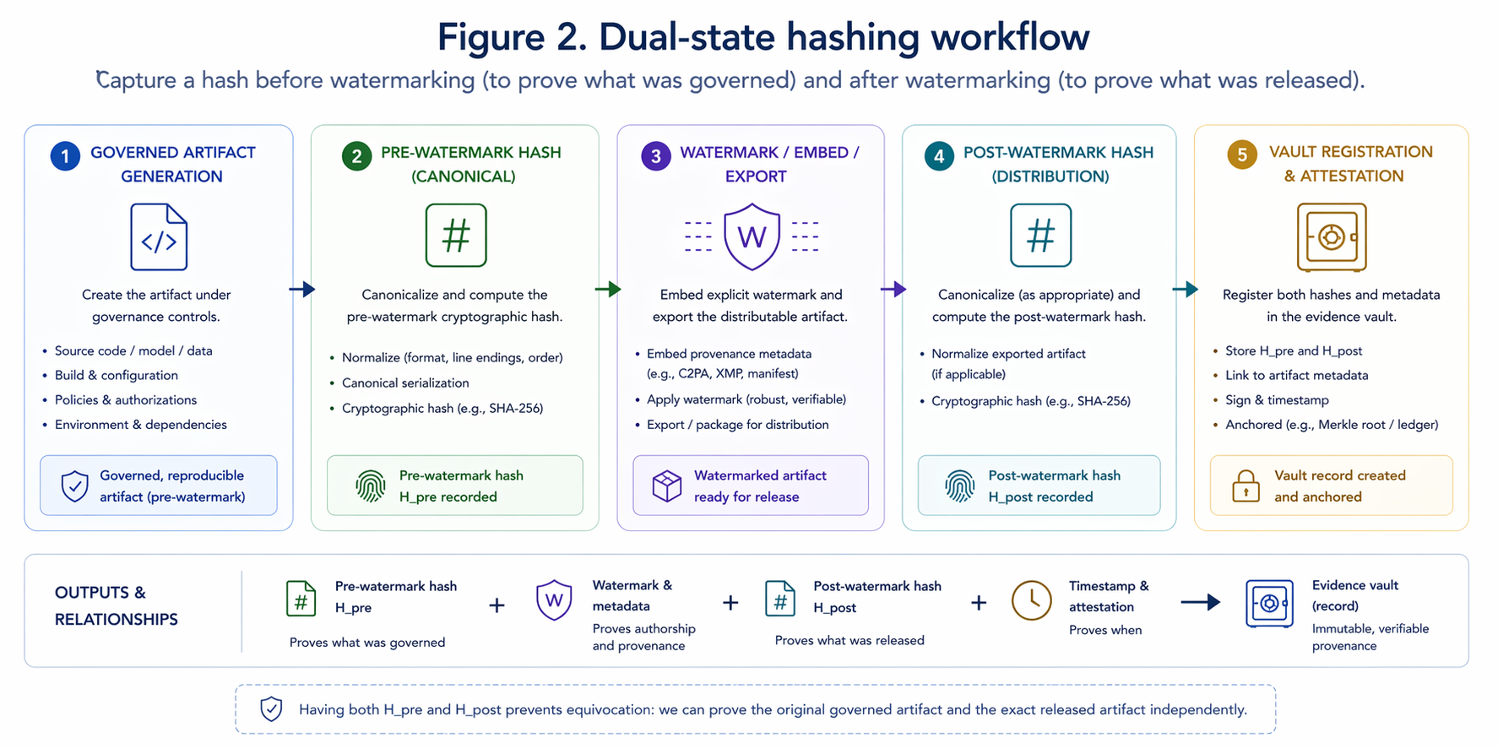
Figure 2. Dual-state hashing workflow
: governed artifact generation -> pre-watermark hash -> watermark/embed/export -> post-watermark hash -> vault registration.

Figure 3. Artifact verification pathway
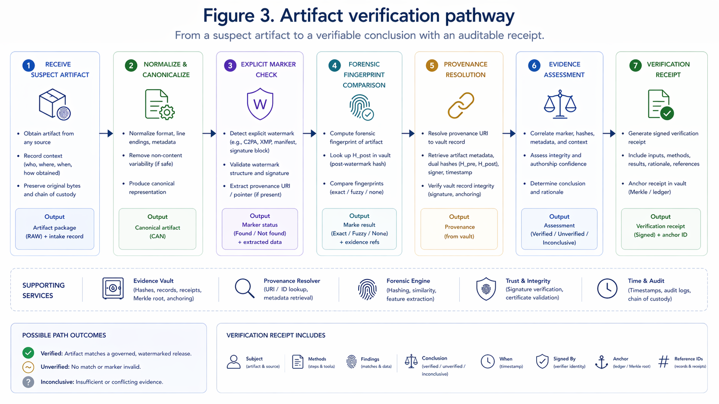
Figure 3. Artifact verification pathway for an investigator workflow from suspect artifact to explicit marker check, forensic fingerprint comparison, and verification receipt.
Figure 3. Artifact verification pathway. Placeholder for an investigator workflow from suspect artifact to explicit marker check, forensic fingerprint comparison, and verification receipt.

Table 1. Comparison of Explicit Watermarking and Forensic Fingerprinting
Dimension | Explicit watermarking | Forensic fingerprinting | Combined value
Primary purpose | Direct origin signaling | Linkage under degradation or dispute | Fast first-pass verification plus fallback evidence
Best when | Artifact remains close to release form | Artifact has been edited, excerpted, or stripped | Mixed real-world handling conditions
Typical strengths | Human-visible, low-friction, easy routing to release record | Persistence under some transformations, supports investigations | Higher resilience than either layer alone
Typical weaknesses | Can be removed, cropped, or stripped | Probabilistic and threshold-sensitive | Requires disciplined claim language and process
Evidence claim | Exact or near-exact released artifact identification | Probable linkage or excerpt relationship | Layered corroboration
Table 1 summarizes the role difference between the two provenance layers and why they should be deployed together rather than treated as competing alternatives.

Table 2. Threat and Transformation Scenarios
Scenario | Impact on explicit layer | Impact on forensic layer | Recommended response
PDF to image conversion | May preserve visible overlay; may strip metadata | Often still matchable through content persistence | Check marker first, then run forensic comparison
Cropping or footer removal | Can remove visible tag entirely | Partial-zone matches may still survive | Escalate to excerpt-sensitive verification
OCR and retyping | Destroys embedded metadata and some visual marks | May reduce match quality depending on errors | Use threshold discipline and corroborating evidence
Paraphrase or rewrite | Usually destroys direct marker linkage | Can defeat text fingerprints if transformation is heavy | Do not overclaim; treat as unsupported absent corroboration
Screenshot leak | Visible mark may survive or be partially obscured | Layout-independent content features may survive | Capture image evidence and compare against release record
Table 2 frames common downstream handling and attack conditions in terms of what each provenance layer can realistically support.

Illustrative Verification Note
Example finding. The suspect PDF no longer contains the visible footer mark used in the released artifact. However, the artifact’s content aligns with the pre-watermark hash lineage and exceeds the organization’s threshold for a 2-of-3 zone distinctive-anchor match. The reviewer can therefore support a limited claim of probable excerpt linkage to the governed release record, not an overbroad claim of untouched-file identity.

Selected References and Adjacent Standards
• Coalition for Content Provenance and Authenticity (C2PA), Technical Specification, a standard for attaching and verifying provenance assertions for media assets.
• NIST AI RMF 1.0, for lifecycle-oriented AI governance and risk management framing.
• Model cards and system transparency literature, for contrast with evidence-bearing provenance records.
• Relevant forensic hashing and perceptual matching literature for artifact comparison under transformation.

AI uses disclosure:

This document, "AI Governance Evidence Infrastructure: A Category Framework for Cryptographically Verifiable AI Lifecycle Accountability," was prepared for concept development and publication planning, dated April 18, 2026. It was authored by Denzil Greenwood, Founder and Head Researcher at CognitiveInsight.ai.
In the creation of this document, AI tools were utilized to generate both the text and the supporting images, with human oversight applied to both processes.

Research Papers and Continued Work: AI Governance Evidence Infrastructure
- Cognitive Insight Audit Framework Lazy Capsule Materialization (CIAF-LCM)
- Tamper-Evident Evidence Vault for AI Lifecycle Events, Decisions, and Audit Packs
- Dual-Layer Provenance for AI-Generated Artifacts: Explicit Watermarks and Forensic Fingerprints as Evidence Infrastructure
- Governance Planes for Agentic AI: Identity, Policy, Privilege, Execution, and Evidence
- Shadow AI Governance: Bringing Unmanaged AI Use into the Evidence Perimeter
- CIAF-LCM Proposed Schema Documentation: Current Schema State, Architecture Fit, and Proposed Documentation Model

